FORNAX™ ePlanCheck Rule
Rule Information
Rule ID | SSW 4.3.3 (e)
Rule Name | Secondary Discharge Stack Diameter ≥ 100 mm
Chapter
Section
Handbook | Code of Practice on Sewerage and Sanitary Works  Addendum - January 2019

Rule Description
    - Sizing Discharge Pipes and Stacks

e. For fully ventilated system and ventilated stack, a secondary discharge stack of diameter not smaller than 100mm shall be provided. The discharge pipes serving the 2nd & 3rd storey (if no discharge pipe connections from the 2nd & 3rd storey, then the next 2 upper storeys of the building) shall be connected to the secondary discharge stack. This secondary stack shall be extended to serve as ventilating stack for the upper storeys.

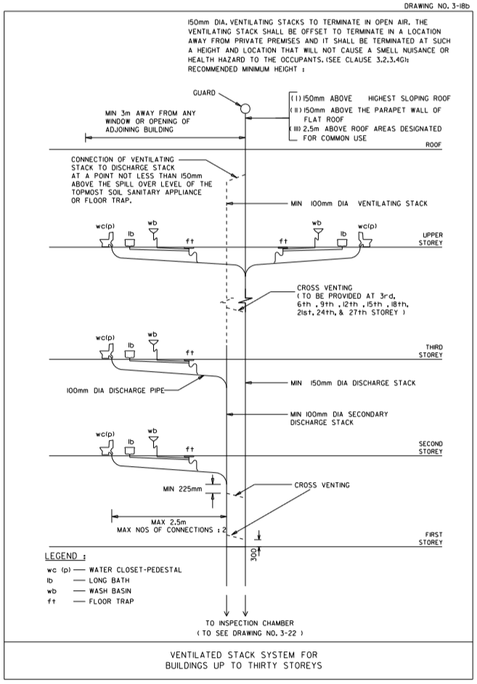

SECONDARY DISCHARGE STACK
MINIMUM DIAMETER 100 mm
VENTILATING STACK
Rule Interpretation
- This rule checks for the diameter of the Secondary Discharge Stack and its connection to the Discharge Pipes in a fully ventilated and ventilated stack system.
- The diameter of the Secondary Discharge Stack must be greater than or equal to 100mm throughout its length.
- Discharge Pipes on lowest 2 stories beginning at Storey 2 must connect to the Secondary Discharge Stack (Figure 01). If there are no Discharge Pipes on Storey 2 and Storey 3, then the Discharge Pipes serving the next two upper stories must connect to the Secondary Discharge Stack.
- No other Discharge Pipe in upper stories are allowed to connect to the Secondary Discharge Stack.

GUARD

MAIN DISCHARGE STACK

DISCHARGE PIPES ON STOREY 2 AND STOREY 3

SECTION
FIGURE 01

Rule Scenario
SECONDARY DISCHARGE STACK
MINIMUM DIAMETER 100 mm
VENTILATING STACK
Scenario 01 – Compliant
Requirement | Minimum diameter of Secondary Discharge Stack is 100 mm throughout its length.  Discharge Pipes on lowest 2 stories must connect to the Secondary Discharge Stack.  No other Discharge Pipe in upper stories is allowed to connect to the Secondary Discharge Stack.
Description | The Secondary Discharge Stack diameter is 100 mm. Discharge Pipes provided on Storey 2 and Storey 3 are connected to the Secondary Discharge Stack. No other connections in the upper stories.
GUARD

MAIN DISCHARGE STACK

DISCHARGE PIPES ON STOREY 2 AND STOREY 3
SECTION
FIGURE SCENARIO

PROHIBITED CONNECTION ON
STOREY 6
SECONDARY DISCHARGE STACK
MINIMUM DIAMETER 100 mm
VENTILATING STACK
PROHIBITED CONNECTION ON
STOREY 6
VENTILATING STACK
Scenario 01 – Non-Compliant 1
Requirement | Minimum diameter of Secondary Discharge Stack is 100 mm throughout its length.  Discharge Pipes on lowest 2 stories must connect to the Secondary Discharge Stack.  No other Discharge Pipe in upper stories is allowed to connect to the Secondary Discharge Stack.
Description | The Secondary Discharge Stack diameter is 80 mm. Discharge Pipes provided on Storey 2 and Storey 3 are not connected to the Secondary Discharge Stack. There is another connection on Storey 6.
GUARD

MAIN DISCHARGE STACK

NOT CONNECTED TO
SECONDARY
DISCHARGE STACK

SECTION
FIGURE SCENARIO

SECONDARY DISCHARGE STACK
MINIMUM DIAMETER 100 mm
PROHIBITED CONNECTION ON
STOREY 6
VENTILATING STACK
Scenario 01 – Non-Compliant 2
Requirement | Minimum diameter of Secondary Discharge Stack is 100 mm throughout its length.  If there are no Discharge Pipes on Storey 2 and Storey 3, then the Discharge Pipes serving the next two upper stories must connect to the Secondary Discharge Stack.  No other Discharge Pipe in upper stories is allowed to connect to the Secondary Discharge Stack.
Description | The Secondary Discharge Stack diameter is 80 mm. Discharge Pipes provided on Storey 4 and Storey 5 are not connected to the Secondary Discharge Stack. There is another connection on Storey 6.
GUARD

MAIN DISCHARGE STACK

NOT CONNECTED TO
SECONDARY
DISCHARGE STACK

SECTION
FIGURE SCENARIO

Request For Information
- What if the connections are not consecutive storeys, for example discharge pipes provided only on 2nd Storey and 5th Storey?

Model PreCheck

Required Elements | Required Attributes
PipeSegment | SystemType contains “Vent”
PipeSegment | ObjectType contains “Discharge Pipe”

Rule Parameters

System Type
Cold Water |  | Vent | ✓
Hot Water |  | Drainage
Sanitary | ✓ | Hydronic
Sewerage |  | Fire Protection
Other

Element Type 1
State | Type | Property | Operator | Value
Include | PipeSegment | Any | N.A. | N.A.
Exclude |  |  | Match | <User define>

Element Type 2
State | Type | Property | Operator | Value
Include | PipeSegment | ObjectType | Contains | Discharge Pipe
Exclude |  | Any | Match | <User define>
 |  |  | N.A. | N.A.

Element Type 1 Condition
Secondary Discharge Stack Minimum diameter | 100 | mm throughout its length
Note:
The Secondary Discharge Stack is the vertical pipe that connects to the Main Discharge Stack.
The Secondary Discharge Stack does not terminate through the roof.

Element Type 2 Condition
Note:
Discharge Pipes on lowest 2 storeys, starting on Storey 2, must connect to the Secondary Discharge Stack.
No other Discharge Pipe in upper stories are allowed to connect to the Secondary Discharge Stack.

Result Messages
- SWD 4.3.3 (e) Secondary Discharge Stack Diameter ≥ 100 mm
  - Non-compliant (TotalResultNumeric)
    - BuildingStorey (TotalResultPerFloorNumeric)
      - Secondary Discharge Stack Diameter: ResultNumeric mm.
    - BuildingStorey (TotalResultPerFloorNumeric)
      - Discharge Pipe on BuildingStorey does not connect to the Secondary Discharge Stack.
    - BuildingStorey (TotalResultPerFloorNumeric)
      - Prohibited Discharge Pipe connection on BuildingStorey.
  - Compliant (TotalResultNumeric)
    - BuildingStorey (TotalResultPerFloorNumeric)
      - Secondary Discharge Stack Diameter: ResultNumeric mm.
    - BuildingStorey (TotalResultPerFloorNumeric)
      - Discharge Pipe on BuildingStorey connects to the Secondary Discharge Stack.
  - Attention (TotalResultNumeric)
    - Building (TotalResultNumeric)
      - Secondary Discharge Stack is not provided.
      - Discharge Pipe is not provided.

Sample Result Messages
- SWD 4.3.3 (e) Secondary Discharge Stack Diameter ≥ 100 mm
  - Non-compliant (4)
    - Storey 1 (1)
      - Secondary Discharge Stack Diameter: 80 mm.
    - Storey 2 (1)
      - Discharge Pipe on Storey 2 does not connect to the Secondary Discharge Stack.
    - Storey 3 (1)
      - Discharge Pipe on Storey 3 does not connect to the Secondary Discharge Stack.
    - Storey 10 (1)
      - Prohibited Discharge Pipe connection on Storey 6.

  - Non-compliant (4)
    - Storey 1 (1)
      - Secondary Discharge Stack Diameter: 80 mm.
    - Storey 4 (1)
      - Discharge Pipe on Storey 4 does not connect to the Secondary Discharge Stack.
    - Storey 5 (1)
      - Discharge Pipe on Storey 5 does not connect to the Secondary Discharge Stack.
    - Storey 12 (1)
      - Prohibited Discharge Pipe connection on Storey 6.

  - Compliant (3)
    - Storey 1 (1)
      - Secondary Discharge Stack Diameter: 100 mm.
    - Storey 2 (1)
      - Discharge Pipe on Storey 2 connects to the Secondary Discharge Stack.
    - Storey 3 (1)
      - Discharge Pipe on Storey 3 connects to the Secondary Discharge Stack.

  - Attention (2)
    - Building (2)
      - Secondary Discharge Stack is not provided.
      - Discharge Pipe is not provided.

Sample Result Model Views
- SWD 4.3.3 (e) Secondary Discharge Stack Diameter ≥ 100 mm
  - Non-Compliant
    - Elevation View
    - Highlight Element Type 1 and Element Type 2 in red.
    - All other elements are translucent except checked elements.
  - Compliant
    - Elevation View
    - Highlight Element Type 1 and Element Type 2 in green.
    - All other elements are translucent except checked elements.

Testing Scenario Notes
      - Scenario 01 Compliant
  - Storey 2 and Storey 3
        - The diameter of the Secondary Discharge Stack is 150 mm. Discharge Pipes on Storey 2 and Storey 3 are connected to the Secondary Discharge Stack.
      - Scenario 01 Non-Compliant 1
  - Storey 1
        - The diameter of the Secondary Discharge Stack is 75 mm.
  - Storey 2 and Storey 3
        - Discharge Pipes on Storey 2 and Storey 3 are not connected to the Secondary Discharge Stack.
  - Storey 10
        - There is a prohibited connection on Storey 6.
      - Scenario 01 Non-Compliant 2
  - Storey 1
        - The diameter of the Secondary Discharge Stack is 75 mm.
  - Storey 4 and Storey 5
        - Discharge Pipes on Storey 2 and Storey 3 are not connected to the Secondary Discharge Stack.
  - Storey 12
        - There is a prohibited connection on Storey 6.

Model:
SWD 4.3.3 (e) Scenario 01 Compliant
SWD 4.3.3 (e) Scenario 01 Non-Compliant 1
SWD 4.3.3 (e) Scenario 01 Non-Compliant 2

Modelling Guideline
- Specify ObjectType containing “Discharge Pipe” for relevant PipeSegment.
- Specify SystemType containing “Vent” for relevant PipeSegment.
- Specify SystemType containing “Sanitary” for relevant PipeSegment.

Specification Log
RA | Delfin M. Ballo, Jr.
Last edit date | 6 December 2018
ePC version
Updates | - V1

Specification Log
RA | Jessica C. Esquerra
Last edit date | 10 January 2019
ePC version
Updates | - V1 – PUB Comments

